How to connect SA - RedHat Linux – WSL2

Goal:
Install Informatica IDMC SaaS secure agent on WSL2 running in Windows 11.
We will install RedHat Linux v9 and then install the secure agent
We will then install Python, mongo db.
We will also connect to SQL Server that’s running on Windows 11 from WSL2
We will then get creative and connect to the Postgres DB that embedded within the secure agent’s process server, we will reuse it to create a custom schema and start acting on it.
NOTE: for all purposes this is over engineering for personal learning.
If you want a simple and straightforward approach then just stick to Windows 11 and install secure agent there, and do not bother about this document.
Date: July 17th
Prepared by Vamsi Vegi for personal notes.

Step 01: get RedHat
https://developers.redhat.com/articles/2025/05/20/getting-started-rhel-windows-subsystem-linux
https://console.redhat.com/insights/image-builder

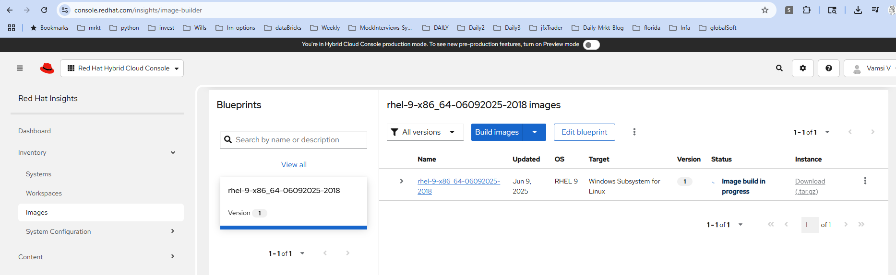

Next create an activation key

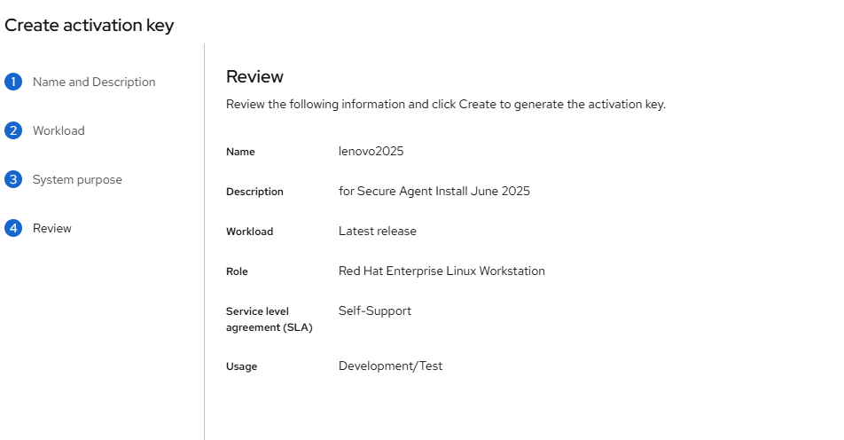
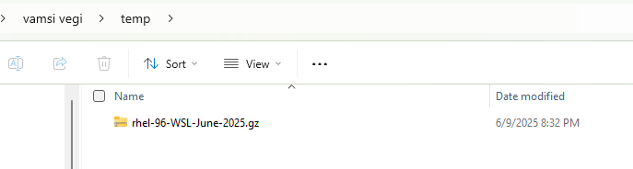

wsl --import rhel-96-WSL-June-2025 .\wsl-rhel-img\rhel96WSLJune2025 C:\Users\vamsi\temp\rhel-96-WSL-June-2025.gz

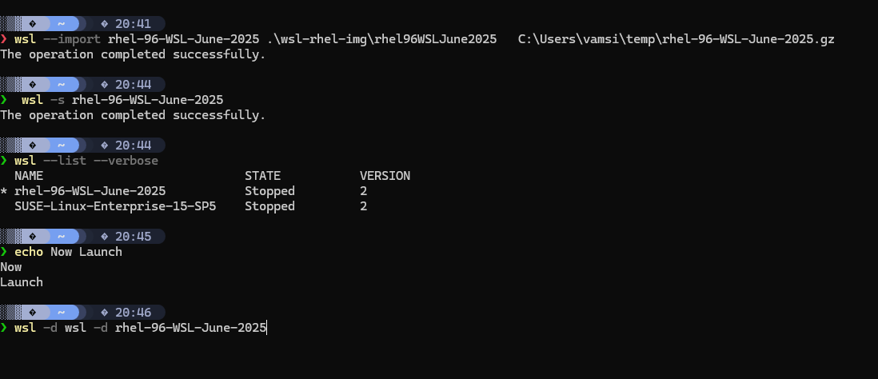

Now launch
Wsl –list --verbose
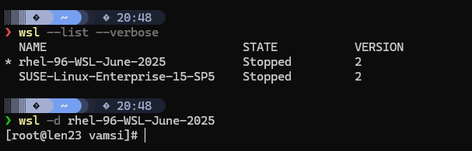

See other cmds

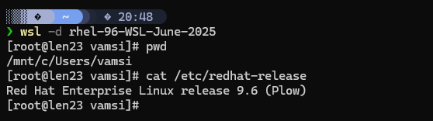

NOTE: Keep this folder and file
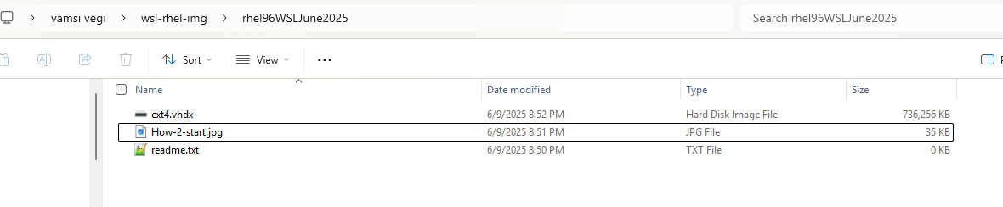

Now change the pwd
rhel-96-WSL-June-2025
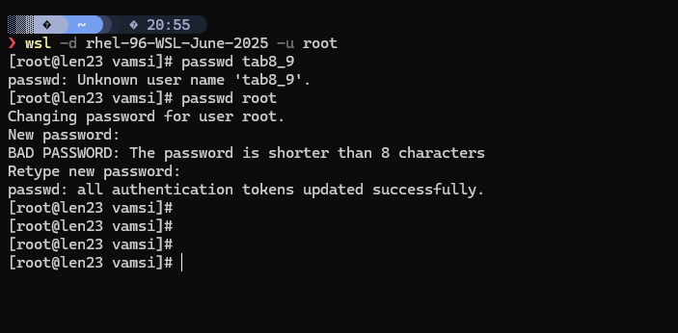

WSL2 RedHat on Len23
useName:root /
pwd= tab8_9
now add a user called sadmin
[root@len23 ~]# sudo useradd sadmin
[root@len23 ~]# sudo passwd sadmin
userName=sadmin
pwd=tab8
Provide the user SADMIN with sudo
>visudo
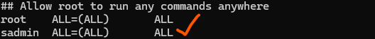

Now install Secure Agent
https://docs.informatica.com/integration-cloud/cloud-data-integration-for-powercenter/current-version/installation-guide/installing-secure-agents/install-the-secure-agent-on-linux/secure-agent-requirements-on-linux.html
sudo yum install libidn2

To know the location of RHEL files when in Windows 11
>explorer.exe . Launches explorer
\\wsl.localhost\rhel-96-WSL-June-2025\usr\lib64

Copy the download SA file here
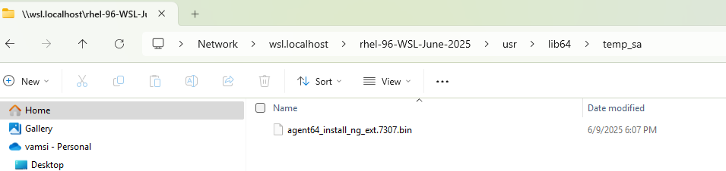

[root@len23 temp_sa]# ./agent64_install_ng_ext.7307.bin -i console
Preparing to install
Extracting the JRE from the installer archive...
Unpacking the JRE...
Extracting the installation resources from the installer archive...
Configuring the installer for this system's environment...

Launching installer...

===============================================================================
Informatica Cloud Secure Agent (created with InstallAnywhere)
-------------------------------------------------------------------------------

Preparing CONSOLE Mode Installation...

===============================================================================
Choose Install Folder
---------------------

Where would you like to install?

Default Install Folder: /root/infaagent

ENTER AN ABSOLUTE PATH, OR PRESS <ENTER> TO ACCEPT THE DEFAULT
:

See
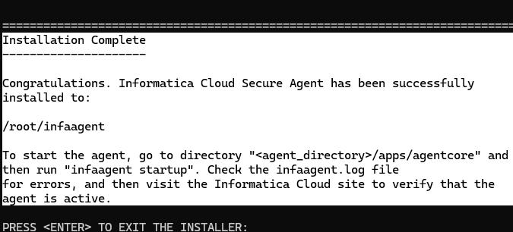
Cd /home/sadmin/infaagent/apps/agentcore
Note: the step to copy the keys and register them is missing here, but its very simple just see the infa documentation

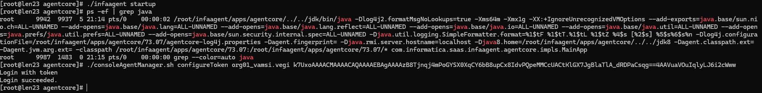

[root@len23 agentcore]# ./infaagent startup
[root@len23 agentcore]# ./consoleAgentManager.sh configureToken org01_vamsi.vegi k7UxoAAAACMAAAACAQAAAAEBAgAAAAzB8Tjnqj4mPoGYSX0XqCY6bB8upCx8IdvPQpeMMCcUACtKlGX7JgBlaTlA_dRDPaCsqg==4AAVuaVOuIqlyLJ6i2cWww
Login with token
Login succeeded.

[root@len23 agentcore]# ps -ef | grep java
root 9942 9937 3 21:14 pts/0 00:00:14 /root/infaagent/apps/agentcore/../../jdk/bin/java -Dlog4j2.formatMsgNoLookups=true -Xms64m -Xmx1g -XX:+IgnoreUnrecognizedVMOptions --add-exports=java.base/sun.nio.ch=ALL-UNNAMED --add-opens=java.base/java.lang=ALL-UNNAMED --add-opens=java.base/java.lang.reflect=ALL-UNNAMED --add-opens=java.base/java.io=ALL-UNNAMED --add-opens=java.base/java.util=ALL-UNNAMED --add-opens=java.prefs/java.util.prefs=ALL-UNNAMED --add-opens=java.base/sun.security.internal.spec=ALL-UNNAMED -Djava.util.logging.SimpleFormatter.format=%1$tF %1$tT.%1$tL %1$tZ %4$s [%2$s] %5$s%6$s%n -Dlog4j.configurationFile=/root/infaagent/apps/agentcore/73.07/agentcore-log4j.properties -Dagent.fingerprint= -Djava.rmi.server.hostname=localhost -Djava8.home=/root/infaagent/apps/agentcore/../../jdk8 -Dagent.classpath.ext= -Dagent.jvm.arg.ext= -classpath /root/infaagent/apps/agentcore/73.07:/root/infaagent/apps/agentcore/73.07/* com.informatica.saas.infaagent.agentcore.impls.MainApp
root 10100 10097 5 21:19 pts/0 00:00:08 /root/infaagent/jdk/bin/java --add-opens=java.base/sun.security.internal.spec=ALL-UNNAMED -Xrs -Xms32m -Xmx128m -Dlog4j.configurationFile=file:log4j.properties -ea -esa -Dinfa.apploader.usessl=true -classpath /root/infaagent/apps/Administrator/1.0.1.1/agent-administrator-app.jar:/root/infaagent/apps/Administrator/1.0.1.1/app-common/*:/root/infaagent/apps/Administrator/1.0.1.1/3rd-party/tomcat/*:/root/infaagent/apps/Administrator/1.0.1.1/3rd-party/other/*:/*: com.informatica.saas.admin.app.Main admin-app.properties
root 10185 1482 12 21:20 pts/0 00:00:18 /root/infaagent/jdk/bin/java -Xms256m -Xmx3072m -XX:+HeapDumpOnOutOfMemoryError -Dlog4j2.formatMsgNoLookups=true -classpath /root/infaagent/downloads/package-OpsInsightsTomcat8.3739/package/lib/*:/root/infaagent/apps/OpsInsightsDataCollector/25.1.1/conf com.informatica.agentapp.tomcateight.App
root 10240 1482 9 21:20 pts/0 00:00:14 /root/infaagent/apps/agentcore/../../jdk8/jre/bin/java -Dloader.path=/root/infaagent/apps/Connector_Service/17.0.1.1/conf -Dserver.port=14815 -Xms32m -Xmx512m -XX:MaxPermSize=128m -DNON_OSGI_ENABLED=true -Dcci_applications_dir=/root/infaagent/apps/Connector_Service/17.0.1.1/apps -Dlog4j1.compatibility=true -Dlog4j2.formatMsgNoLookups=true -Dlog4j.configuration=file:/root/infaagent/apps/Connector_Service/ext/log4j.properties -Dinfa.apploader.usessl=true -Djava.library.path=/root/infaagent/apps/Connector_Service/17.0.1.1/ICS/main/bin/rdtm:/root/infaagent/apps/Connector_Service/17.0.1.1/ICS/main/cci/bin:/root/infaagent/apps/agentcore/../../jdk8/jre/bin -cp /root/infaagent/apps/Connector_Service/17.0.1.1/lib/agentapp/* com.infa.cci.startup.CCIAppStartup
root 10534 1483 0 21:22 pts/0 00:00:00 grep --color=auto java
[root@len23 agentcore]#

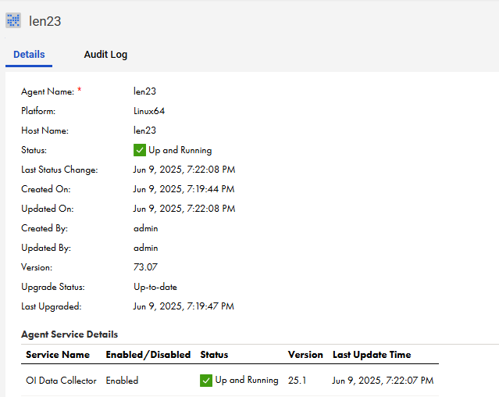
Lets insall the SQL tools in WSLs
https://learn.microsoft.com/en-us/sql/linux/sql-server-linux-setup-tools?view=sql-server-ver17&tabs=redhat-install

redHat 9: curl https://packages.microsoft.com/config/rhel/9/prod.repo | sudo tee /etc/yum.repos.d/mssql-release.repo

SWITCH TO WINDOWS
---------------------------- Local LEN23 SQL Server --------------

SQL Server – July 12
Note Enable

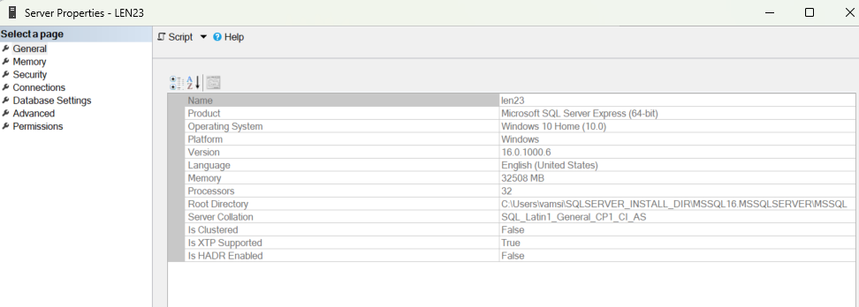
Open firewall
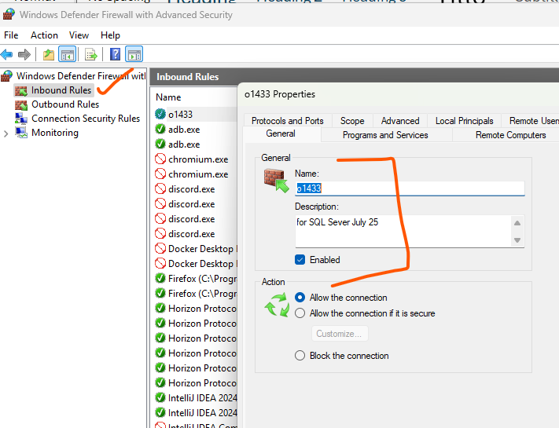

Name=len23
SQLServerManager16.msc enable TCP/IP
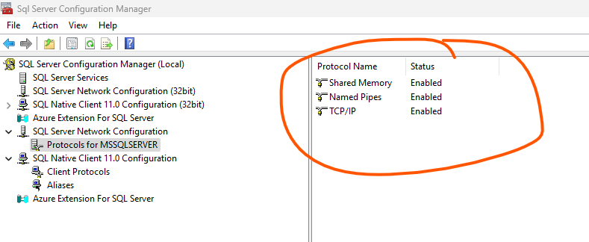

ALTER LOGIN [sa] ENABLE
Pwd= sadmin123
GO

sa/sadmin123
cmx_ors/cmx123
sam_ors/sam123

instal cmd tools
https://go.microsoft.com/fwlink/?linkid=2142258
tryit:
sqlcmd -S len23 -U sam_ors -P sam123

------------------------------------------- NOW SWTICH TO WSL2 RedHat -----
Install the sqlcmd on RHEL 9
https://learn.microsoft.com/en-us/sql/linux/sql-server-linux-setup-tools?view=sql-server-ver17&tabs=redhat-install#RHEL

test
sqlcmd -S 172.26.224.1 -U sa -P sadmin123 -No
Hint: “172.26.224.1” is got from windows cmd ipconfig.exe /all now goto Ethernet adapter vEthernet (WSL (Hyper-V firewall)):

sqlcmd -S 172.26.224.1 -U sam_ors -P sam123 -No
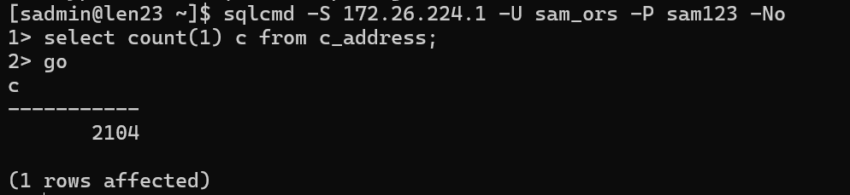

---------------- now install Python 3.11 ---------------------------
Login as root
dnf install python3.11
dnf install python3-pip
[root@len23 vamsi]# python3 --version

Now goback to SADMIN login and check
Which python3

------------------- now install MongoDB community Edition --------------------
https://www.mongodb.com/docs/manual/tutorial/install-mongodb-on-red-hat/#std-label-install-mdb-community-redhat-centos
we will install unde r the SADMIN
[sadmin@len23 dwnlds]$ wget "https://fastdl.mongodb.org/linux/mongodb-linux-x86_64-rhel90-7.0.21.tgz" mongo_rhel_9.tgz
Make dirs
[sadmin@len23 ~]$ mkdir -p ~/mongo/data/db
[sadmin@len23 ~]$ mkdir -p ~/mongo/logs
Create a mongod.conf file (or modify an existing one) to specify the data and log paths:
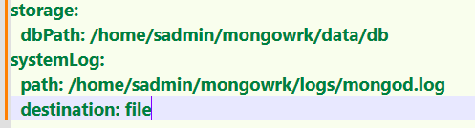
[sadmin@len23 bin]$ pwd
/home/sadmin/mongodb/bin
Create a start_mongo.sh file
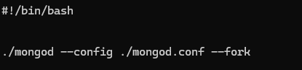
Now chmod + x and start

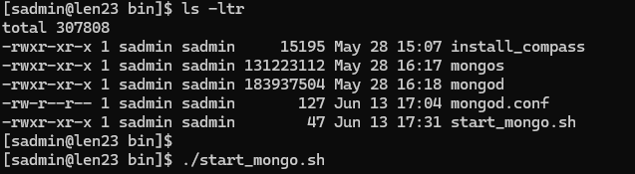

--
--------------------Lets install the compass in the Linux (but I do not prefer this) -------------------------------
There is an install compass script already in the prev unzip
Run it in sudo mode

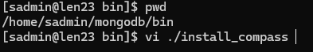
edit
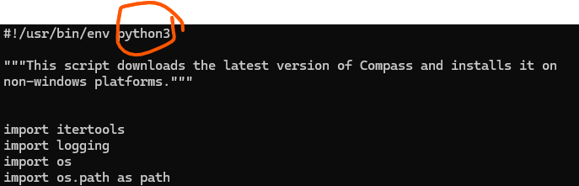

Install it
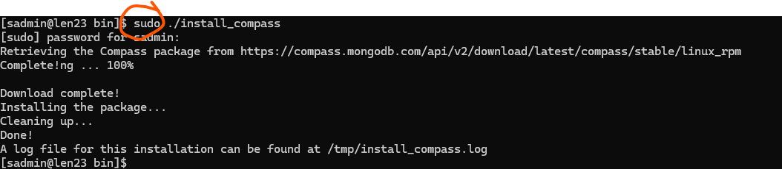

We will install the mongo compass in the Windows
Goto https://www.mongodb.com/try/download/compass

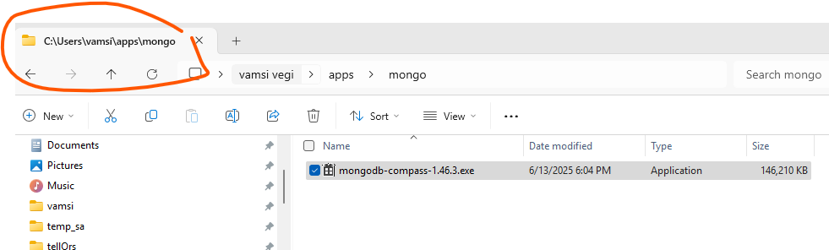

Download the exe, no need to install

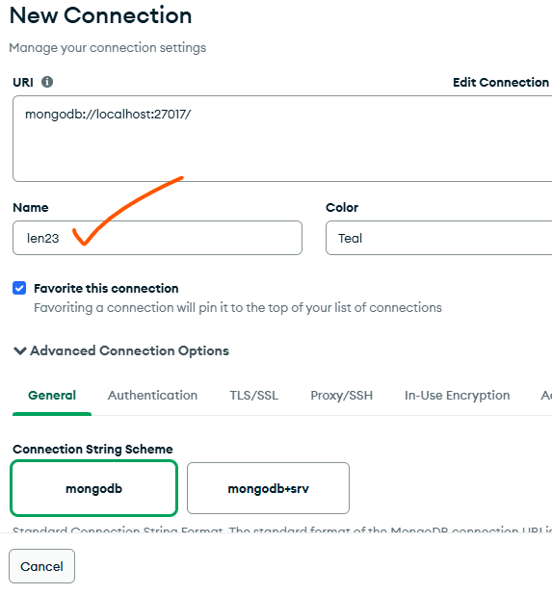

https://www.digitalocean.com/community/tutorials/how-to-use-mongodb-compass
---------------------- now lets connect to the Postgres DB as used by the Process server ------------
Using DBBeaver, connect and check
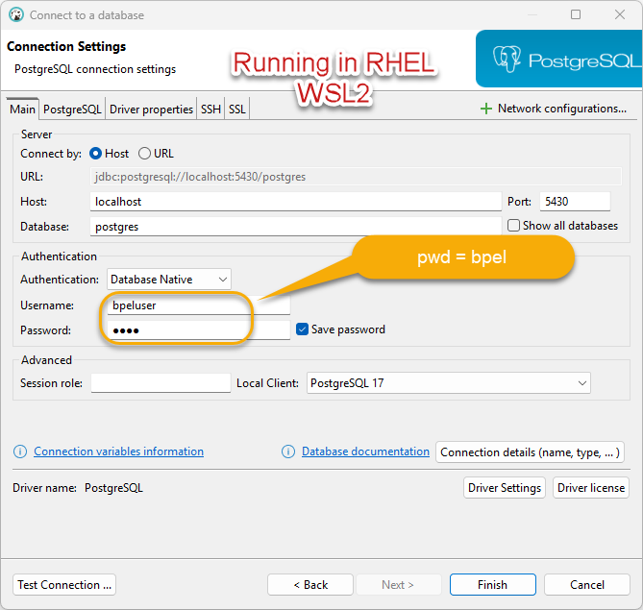

Now create a DB usingf DBBeaver UI

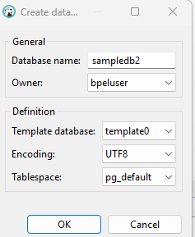

Now logout from the perv and create a new connection as shown
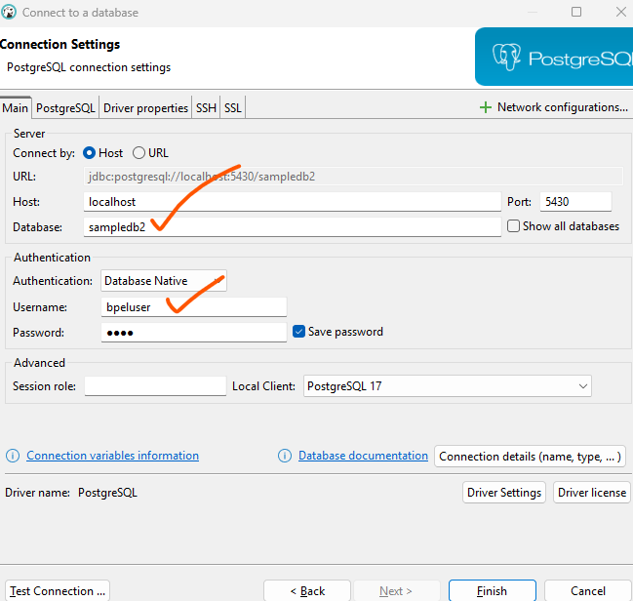

Now connect as you will see you are connected to sampledb2
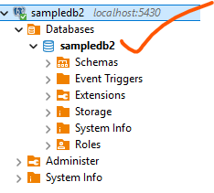
Now open a script
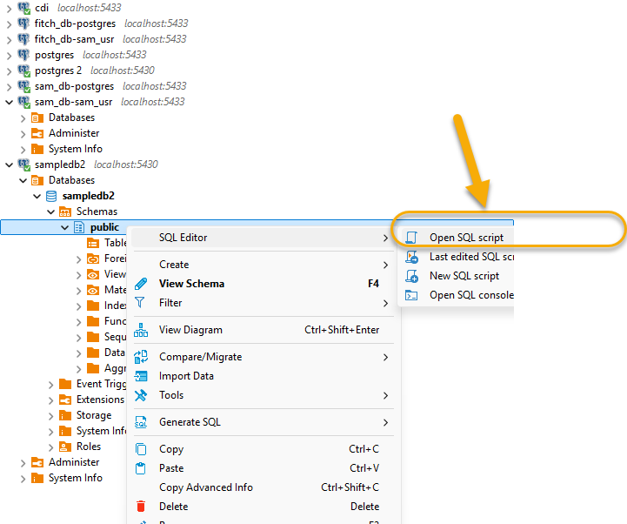

You can verify the conn as below
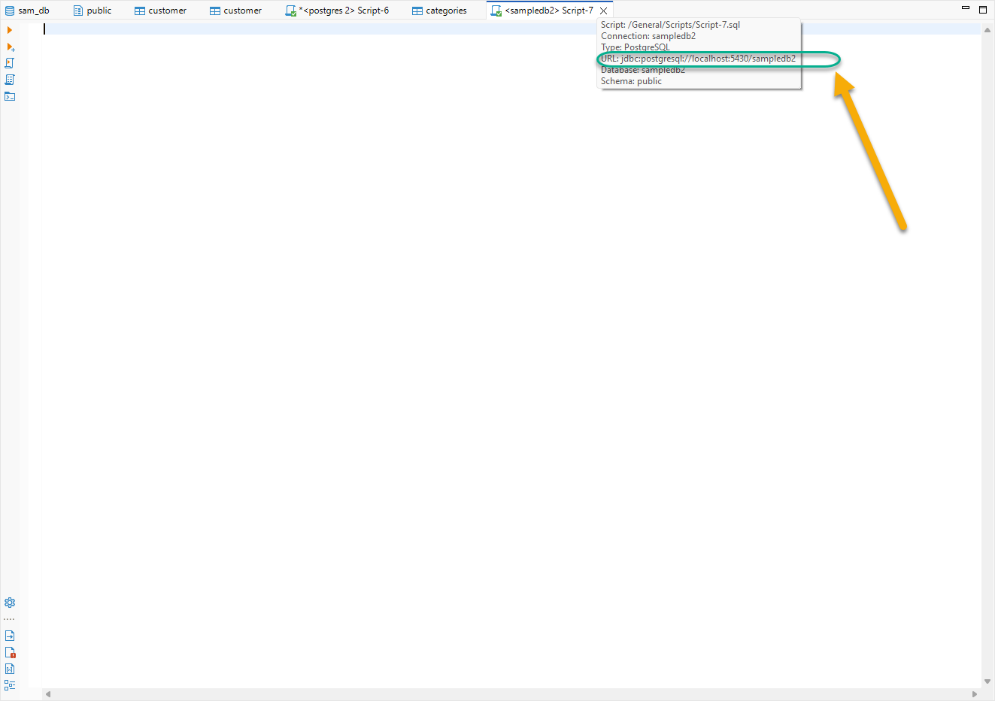

Import the NorthWind DB
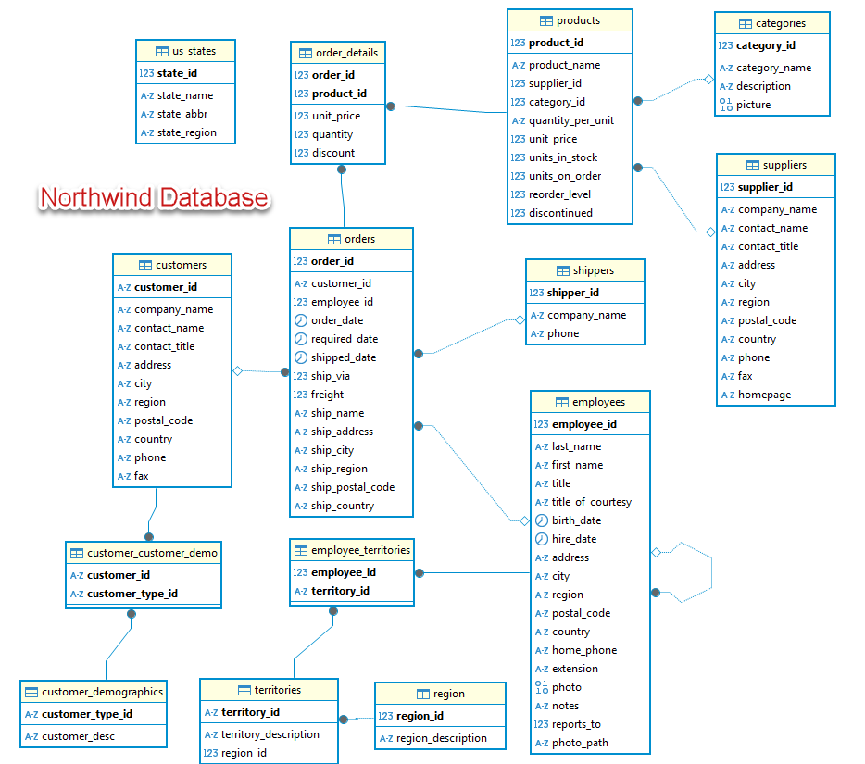

Now you can run the below script
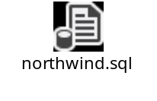
From https://github.com/pthom/northwind_psql/blob/master/northwind.sql
Once run you can see the tables and the data
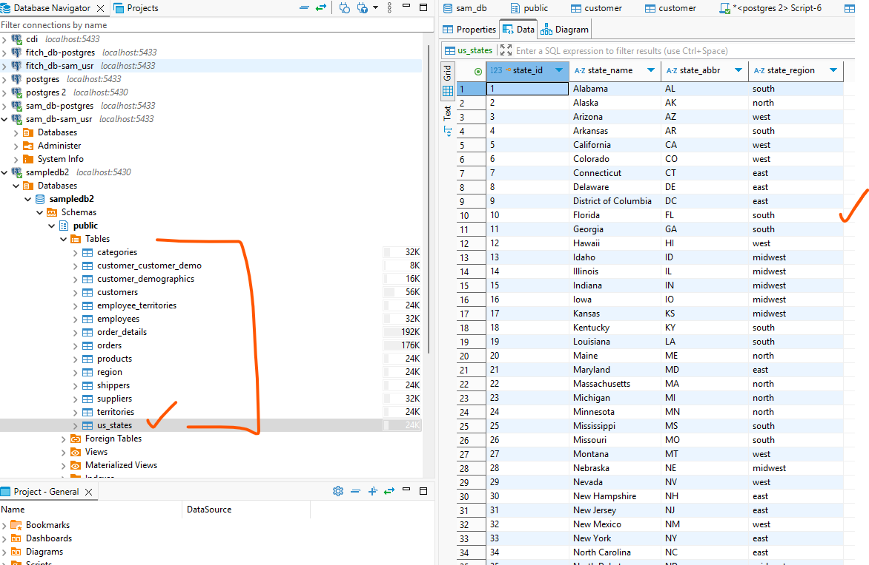

create a connection on the Secure Agent and test it

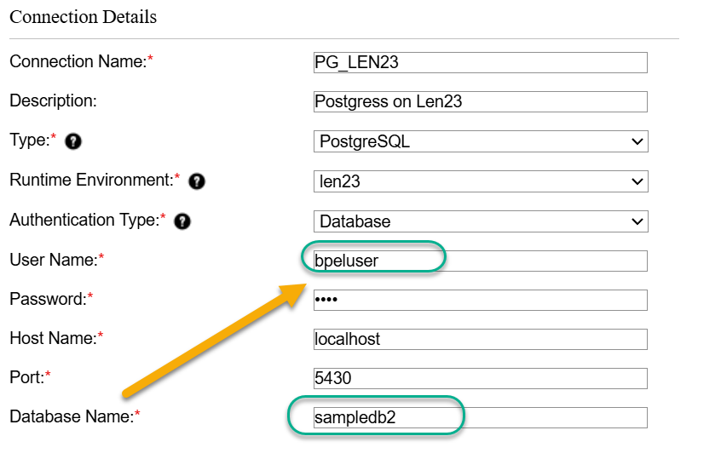

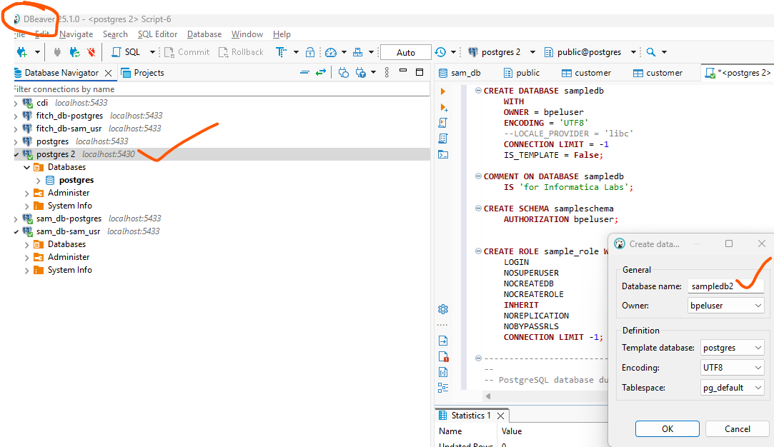

----------------- now for MongoDB ---------------------------
s
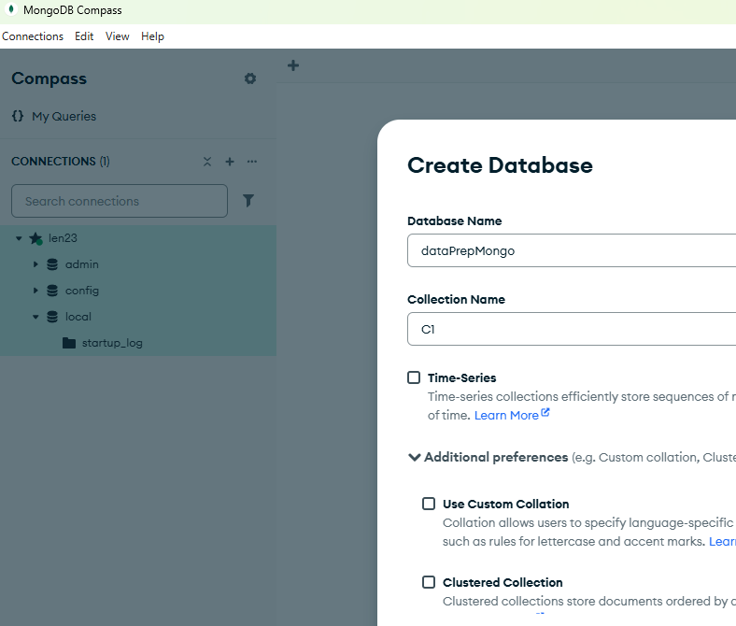
s
check it in secure agent
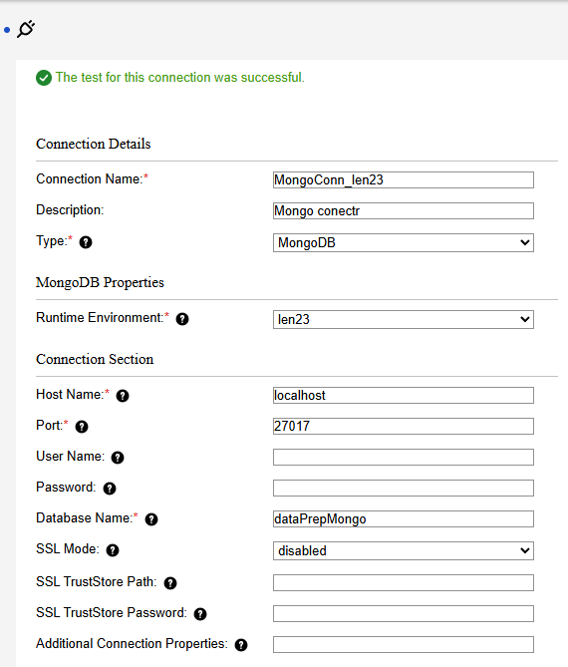

H2

H3

